|  |
| --- |
| [Type the company name] |
| Installing SQL Server 2005 |
| Windows Server 2008 R2 Datacenter – 64bit |

|  |
| --- |
|  |

# Installing Microsoft SQL Server 2005 Express

* 1. Double Click on **“Setup.exe”**

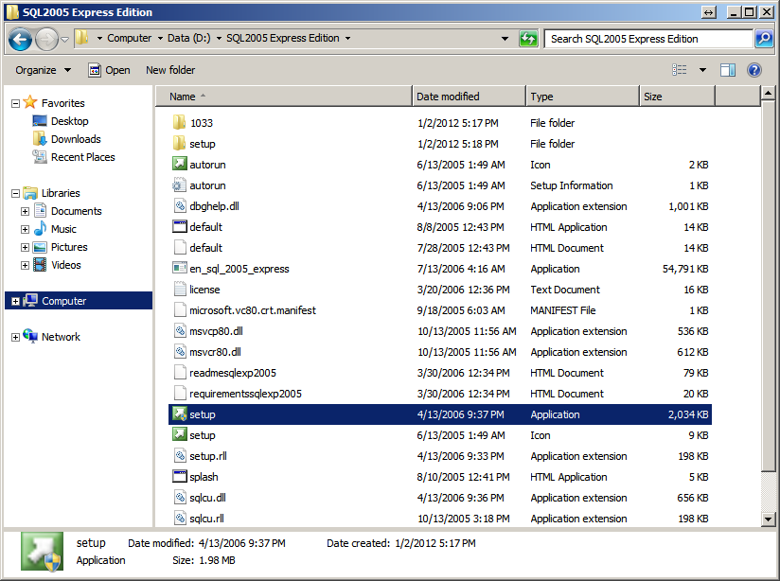

Figure 1: Setup

* 1. Click **“Run Program”**

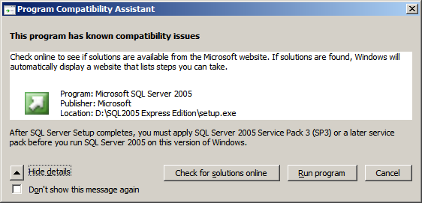

Figure 2: Compatibility Assistant

*Note: You must apply SQL Server Pack 3 later to function properly*

* 1. Click **“Next >”**

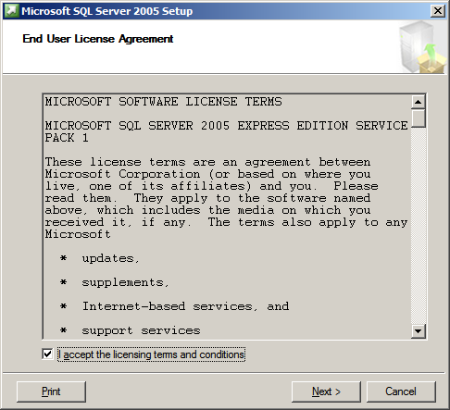

Figure 3: End User License Agreement

* 1. Click **“Install”**

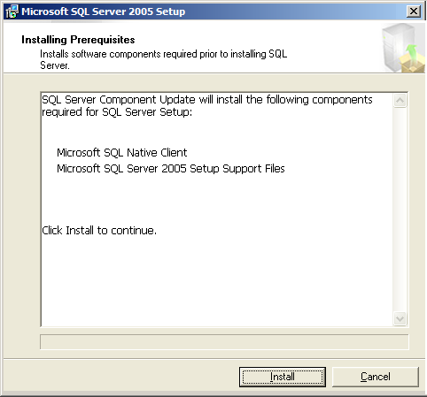

Figure 4: Installing Prerequisites

* 1. Click **“Next >”**

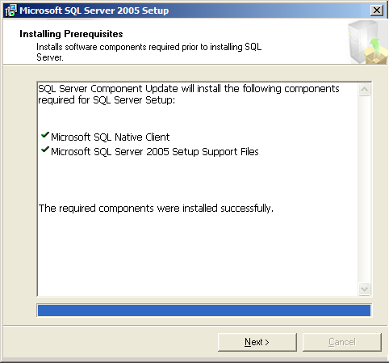

Figure 5: Installing Prerequisites

* 1. Click **“Next >”**

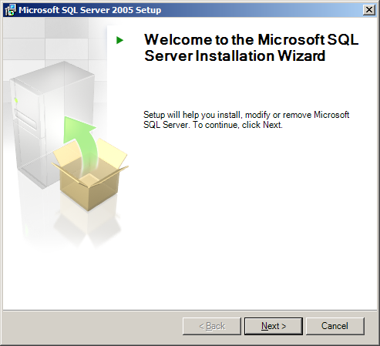

Figure 6: Installation wizard

* 1. Click **“Next >”**

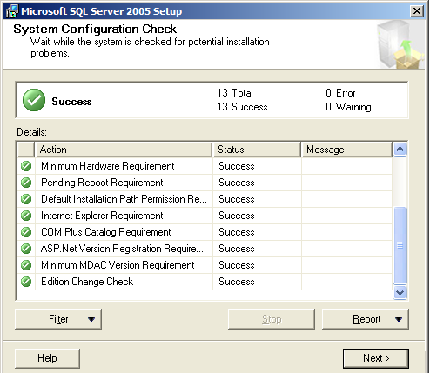

Figure 7: System Configuration Check

* 1. Click **“Next >”**

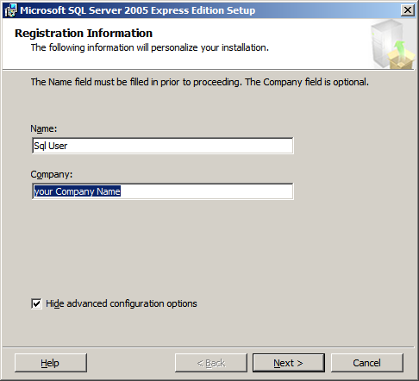

Figure 8: Registration Information

* 1. Click **“Next >”**

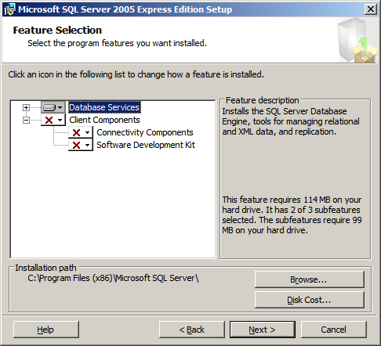

Figure 9: Feature selection

* 1. Select **“Default Instance”**
  2. Click **“Next >”**

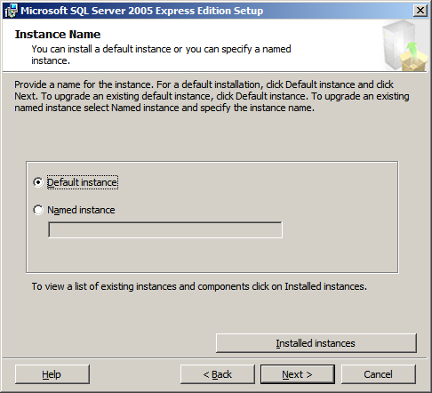

* 1. Select **“Mixed Mode (Windows authentication and SQL Server authentication)”**
  2. Enter Password in **“Enter password”** text field.
  3. Enter Same Password in **“Confirm password”** text field.
  4. Click **“Next >”**

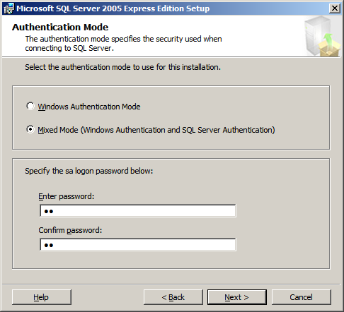

Figure 10: Authentication Mode

* 1. Click **“Next >”**

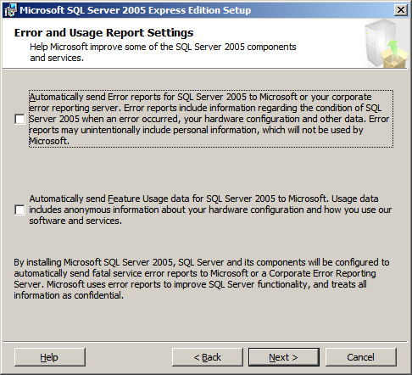

Figure 11: Error and Usage Report settings

* 1. Click **“Install”**

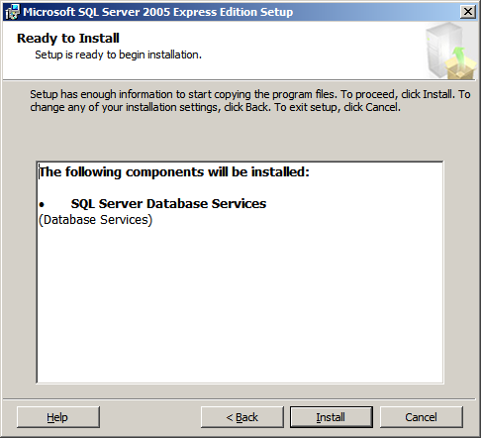

Figure 12: Ready to Install

* 1. Click **“Next >>”**

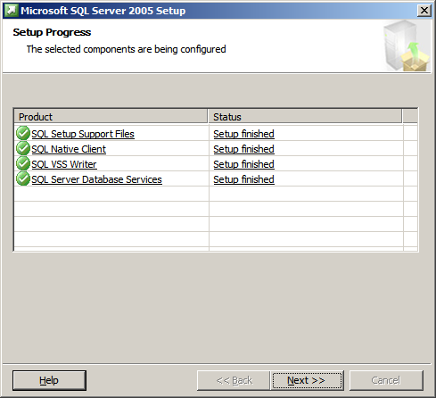

Figure 13: Setup progress

* 1. Click **“Finish”**

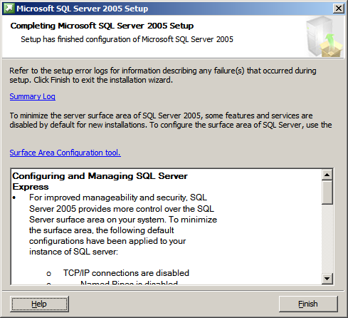

Figure 14: Completing Microsoft SQL Server 2005 Setup